**CNM Grant Procurement Memo**

Applies to:

Funding source (choose one):

State Federal

* Federal purchases $10,000 and above or,
* State purchases $20,000 and above
* Purchases less than $60,000

**Grant/Project Title:** Dept of Education-Quantum Learning Lab

**Project Director/PI:** Brian Rashap

**Grant number within Workday:** GR300429

**Description of goods or services:** Short description of what is needed

Quantum

**Benefit to grant and CNM:** Describe how/why this purchase will meet objectives of project.

Increase the number of students able to be trained from 3 to 6, as well as add on capabilities around quantum phenomenon.

**Estimated dollar amount:** $48,247.76

**Rationale for method of procurement:** Describe how quotes were gathered

Direct Quotes from Vendors

**Contractor selection or rejection:**  Name each vendor and indicate whether selected or rejected. This will document and justify the decision for procurement.

* VENDOR #1: ThorLabs
  + ThorLabs: ACCEPTED
  + Amount of Quote: $48,247.76
  + Justification: Lowest Quote. Matches current setup and allows for expansion.
* VENDOR #2: QuTools
  + QuTools: REJECTED
  + Amount of Quote: $95,000 (or $65,000 without NV setup)
  + Justification: Move expensive and less compatible with learning objectives.
* VENDOR #3: SpinQ
  + Newport / MKS: REJECTED
  + Amount of Quote: $50,000+
  + Justification: Chinese company (not manufacturing is US). Expensive.

**VENDOR #1: ThorLabs**

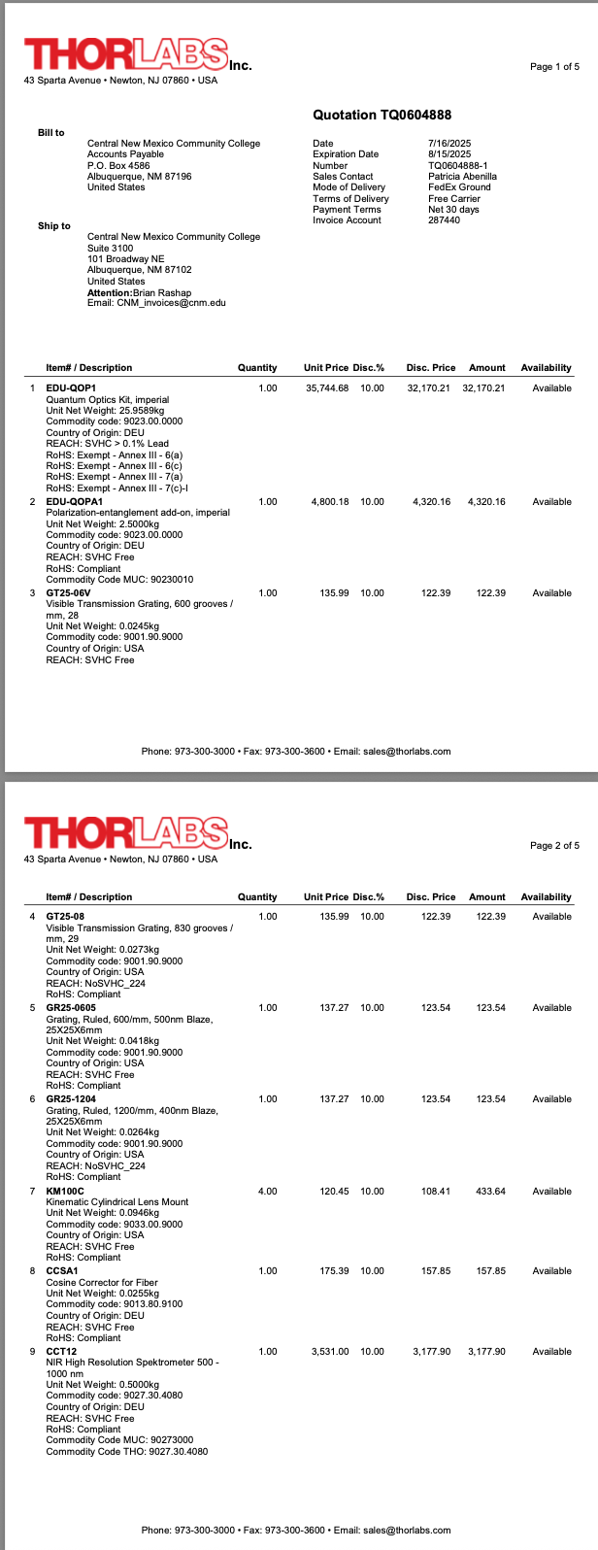

**VENDOR # 2**

**VENDOR #3: SpinQ**



How Much Is a Quantum Computer?

The prices of quantum computers can vary significantly depending on the type of quantum computer, scale, and intended use of the quantum system.

Here's an overview of general pricing:

**1. Educational and Small-Scale Quantum Computers Price**

**Price Range: Starting from $50,000**

These quantum computers are designed primarily for educational purposes, quantum learning, and experimentation with quantum algorithms.

They may have limited qubits and less advanced performance compared with large-scale commercial quantum systems. However, they are relatively cheap and accessible for schools, universities, and research labs.

**Example:** [***SpinQ's Gemini Mini***](https://www.spinquanta.com/products-services/geminiMini) and [***Triangulum Mini***](https://www.spinquanta.com/products-services/triangulumMini)series are compact, room-temperature quantum computers designed for educational use. They are affordable, portable, easy to maintain, and perfect for introducing students to quantum principles.